

NETWORK SECURITY PROJECT
  - CYSC H1001 – NETWORK SECURITY PROJECT


B00169434 Velen Tikhonov (G8)
B00169239 Scott Overton (G5)
B00174492 Samuel Sebastine (G8)

Table of Contents
Aim of this presentation 3
Internet Protection fire – Ipfire 3
Aims 3
Setup of ipfire 4
Access Gui 5
Creating firewall rules 6
Showing rules in action 7
Exploiting the fire wall 7
Part one 7
Part Two 8
Ipfire conclusion 9
NFTables 9
Aims 10
Network topology 10
Comparison 16
Conclusion 16
Smoothwall 16
Aims 17
The following tests were done: 17
Topology 17
Testing Setup 18
Iptables rules 19
Testing with Firewall Enabled 20
Firewall enabled vs disabled 25
The comparison between firewall on vs off 27
Result Analysis 27
Conclusion 28
Final conclusion 29
Reference list 30

Aim of this presentation
This project aims to show the difference between 3 types of firewalls and their advantages and disadvantages. We will also stress test these firewalls with certain common attacks.
The 3 types of firewalls we will discuss are
- Ipfire.
- NFtables.
- Smoothwall.

Internet Protection fire – Ipfire
(B00169239) (Group 5)
Ip fire is a new and updated ipcop, ipcop was last updated in 2015 and so it’s not very secure however in 2007 a team who were open-source enthusiasts forked code from ipcop as they felt it needed an updated Linux kernel and wanted ‘transparency in the hands of users. Like ipcop it was created as a small open-source firewall for homes and small businesses which has a lot of benefits however is maintained and updated regularly
It has a community bored to ask for help as it’s a good new comer firewall and doesn’t rely to much on linux commands but would help to understand linux. Listed are a few of its features
- Content filtering
- DCHP server
- Easy setup
- Intrusion detection
- Firewall rules
- Firewall grouping

Aims
In my test I will show ipfire working on a virtual machine with having a red and a green line which will allow two pcs to talk to one another, Using the online GUI I will allow a pc on the red line to accesses the online web, SSH to the terminal and ping inside the network (normally locked to internal network).
After that is showing to work I will introduce a new computer to the red interface and will be malicious and try to ping flood the firewall but because of its in-built security features it will log and block the Ip.

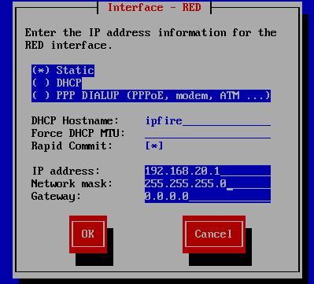
Setup of ipfire
I set up my 2 virtual machines and have setup the ipfire as shown in the image where I am configuring the red and green interfaces.

In the images you can see the red interface has been given an Ip of 192.168.20.1 by selecting the static I can manually set the Ip, this makes setup a lot easier.

The green interface has been given the Ip of 192.168.10.1.
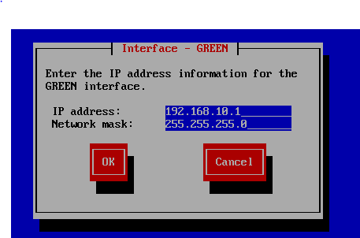
the green interface is noted as my internal network meaning that any device on the green network is protected by foreign ips and later on will go into details on the rules regarding these such as ping flood protection.

Access Gui
During configuration you are prompted to issue a password for your control Pannell, where you can set up services mentioned such as DCHP and URL filter as examples. It’s also where logs are stored which will be mentioned later on regarding malicious and friendly users on the red interface. 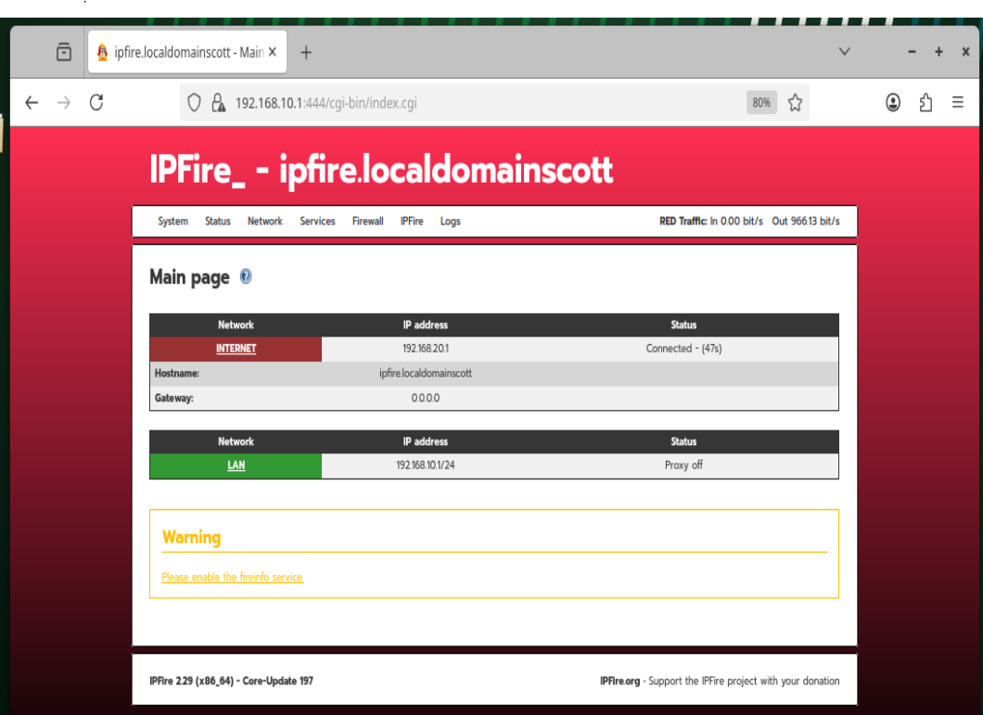
You can see my 2 interfaces are shown. To allow my pcs to connect and actually get the firewall protection it’s just a matter of connecting them up by default gateway.
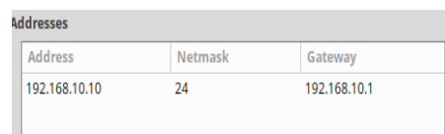
pc on green interface showing default gateway. This connection shows how easy ipfire is to set up on machines and its user-friendly setup.

Creating firewall rules
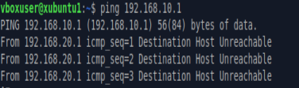
Before I set up my rules if I am to ping from pc-red to pc-green I receive the below error, Ipfire sees my ICMP request denies the packet
this would be the same for SSH and also trying to connect to the online Gui.
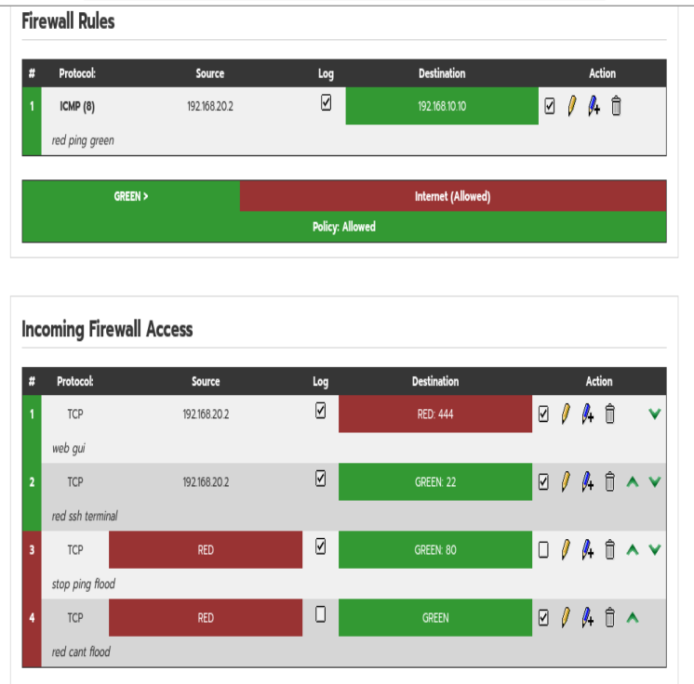
It’s very easy to set up firewall rules on ipfire as shown in the image above and is basically whitelisting my red pc to ping the green pc. These rules allow red pc to ssh terminal and accsess the web gui and ping into the green network to green pc.

Showing rules in action
The image shows a suscessful ping and ssh from the red interface, normally these ports would be blocked but because the rules were set it works easily.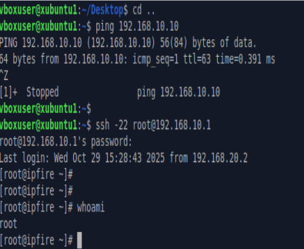

Exploiting the fire wall
With my firewall set up and working there needs to be some testing such as joining default gateway and trying to ping inside the gateway and ssh termianl and do a ping flood and an Nmap scan showing open ports.

Part one
My first attempt will be doing a ping flood using Hping which allows for mulitple pakcetsto be sent as a stress test for a firewall and how we will add a rule to block and deny all traffic on the red that trys to syn flood with ipfires settings
Using Hping3 we flood the green interface which will send as many packects as possible which will slow down the firewall. Using top command in the firewall terminal we can see the spike in CPU usage.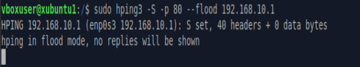
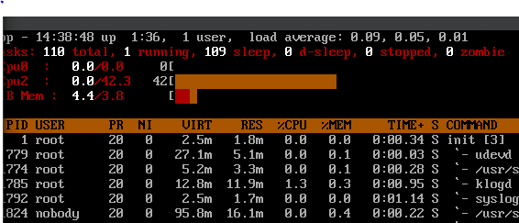
This is clearly showing the firewall cpu is being flooded with requests.
These rules below make it clear that any pings will be dropped and these can be seen when the test is repeated.
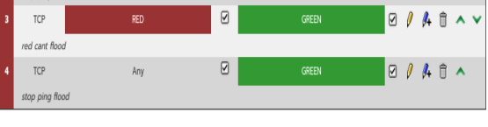
Reading the firewall logs it can be noted that all packets sent to the green interface were dropped. Showing a success in my firewall.
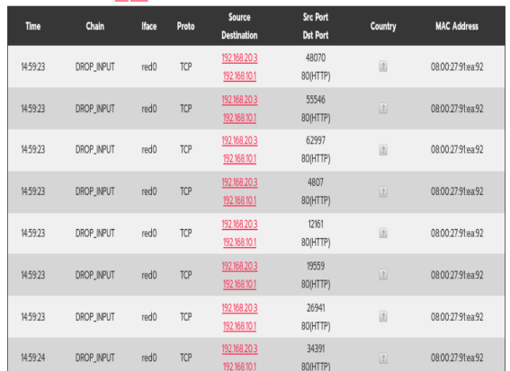

Part Two
I will be doing a simple Nmap scan to my green default gateway. Normally Nmap would block any scan on green interface, by design Nmap will block port scans however cause the 192.168.20 whitelist. Using ipfires simple rules a simple block all protocols just in case.
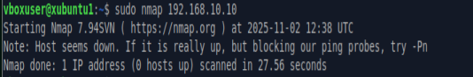

Ipfire conclusion
Keep it short and sweet which is ipfire is simple once the gui website is found and rules can be created as they apply instantly to the firewall. However, during installation ipfire can go wrong such as wrong default gateways or selecting the wrong color layout. Firewall logging can also be confusing.

NFTables
(B00169434) (Group 8)
Introduction to Nftables
Nftables is the modern kernel packet classification framework for Linux systems, released by the Netfilter Project in January 19 2014 as the successor of iptables for Linux network administrators and developers which was constantly being modified with hundreds of extensions since the late 1990’s. (Netfilter Project,2025)
Nftables is more powerful than iptables in many ways, for example managing packet filtering and NAT (Network address translation), Nftables is easy to set up and sometimes comes preinstalled on Linux based operating systems in pair with ufw. It is regularly updated which eliminates vulnerabilities, its benefits include:
- Efficient executing
- Improved error reporting
- Reduction of code duplication
- Storage
- API that allows automatic replacement of one or more Firewalls within one Netlink transaction
(Y Combinator 2017)

Aims
My aim is to evaluate the effectiveness of nftables firewall protection through multiple tests. My testing environment has 3 virtual machines the client which has a linux mint operating system, the firewall server which has an ubuntu operating system with a nftables firewall and the attacker which uses the kali linux operating system. The client and server will be on an internal network which I will need to protect with the firewall from the attacker that will be on an attack network with the server, in real life the attack network would be like a public wifi in a cafe. The type of tests and attacks include:
- Port scanning using Nmap
- Web service assessment using Nikto to identify web vulnerabilities
- ICMP flood attacks using Hping3 to test denial-of-service resilience
First, I will conduct these tests with no firewall in place to see the results and vulnerabilities that are present. After I will set Nftable Firewall rules in place and run the tests again and compare the before and after results.

Network topology
This is how my network looks like, the server has two interfaces and it will filter traffic using nftables forward chain
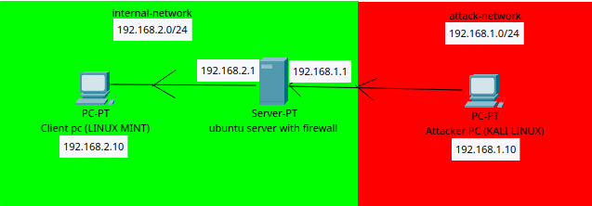
Client Ip

Server Ip
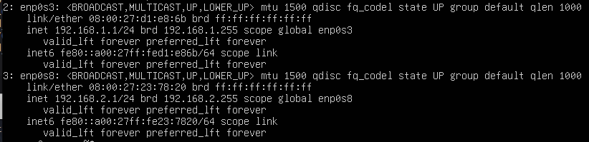
Attacker Ip
Testing with no firewall
First, I installed apache webserver on my client
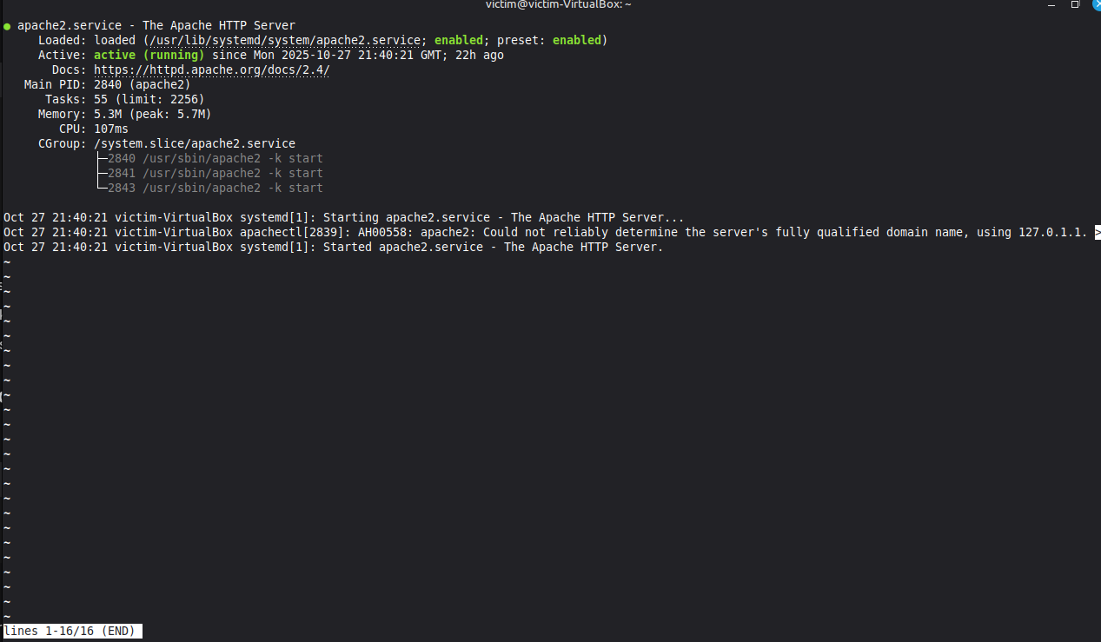
secondly, I disabled my firewalls on the client and server.

Test 1: Nmap scan with no firewall
Then I proceeded with my first test which was Nmap scanning open ports on the clients Ip 192.168.2.10 :
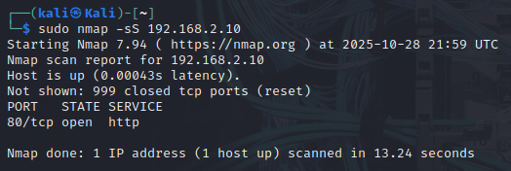
As a result, it was revealed that port 80 (HTTP) was open while 999 other ports responded with reset packets indicating they are closed but detectable the scan completed fast in 13.24 seconds, the results show attackers can see all ports and identify running services and what they can potentially attack
Test 2: web service assessment with nikto and no firewall
Second test was to assess the web service using nikto
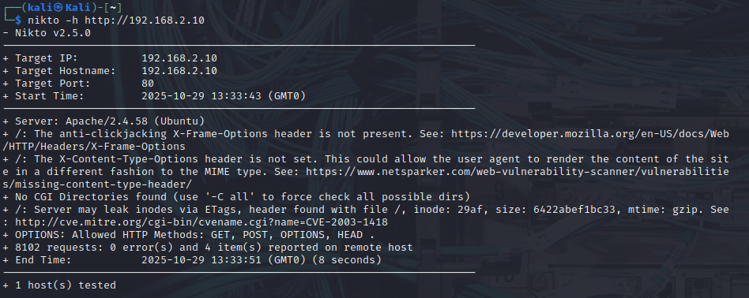
This scan revealed our apache webservers version and os, it’s fully accessible to attacker and legitimate traffic

Test 3: icmp flooding with hping3
And for the final no firewall test i used hping3
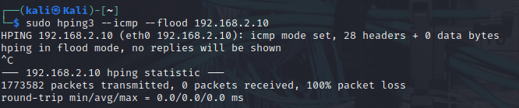
1.7 million packets were sent, 100% packet loss, no rate limiting service was unresponsive during attack
Testing with firewall
After I installed nftables and set the rules
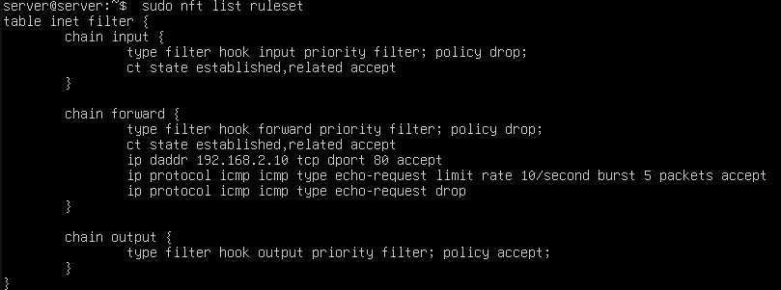
The rules made it so 192.168.2.10 accepted packet with a rate limit of 10 and instead of denying packets it would drop them
Test 4: port scan with nmap and firewall
Since the firewall is set I tested it with a Nmap scan
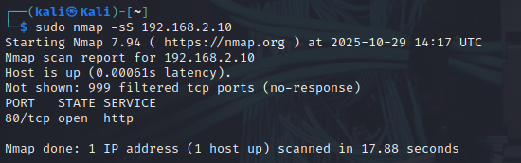
For the results this time the packets where silently filtered and dropped and the scan took longer, port 80 is still accessible for legit traffic so we blocked access to other 999 ports while allowing port 80 only for legitimate use
Test 5 : Web service assessment with nikto and a firewall
This time I used nikto with the firewall enabled 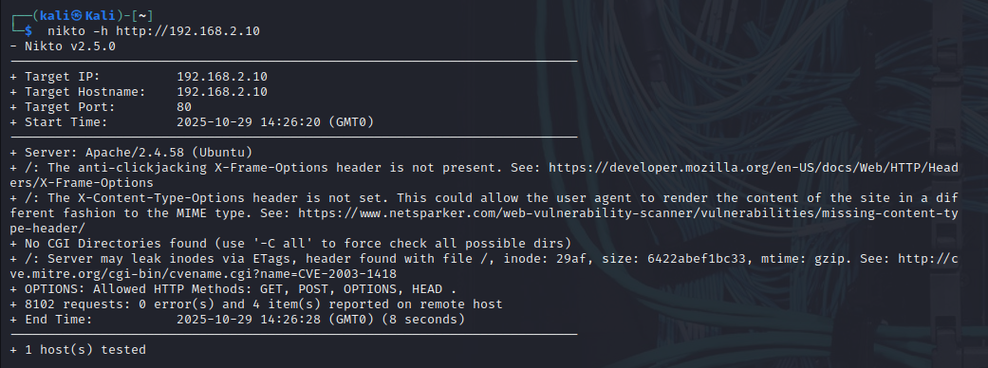
The nikto scan showed the same results even with the firewall, because it uses web traffic on port 80 which I allowed the firewall blocks network attacks but not web vulnerability scans since they look like regular website visitors
Test 6 : Icmp flooding with firewall enabled
And for the final test we icmp flood attacked the server with the firewall enabled 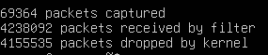
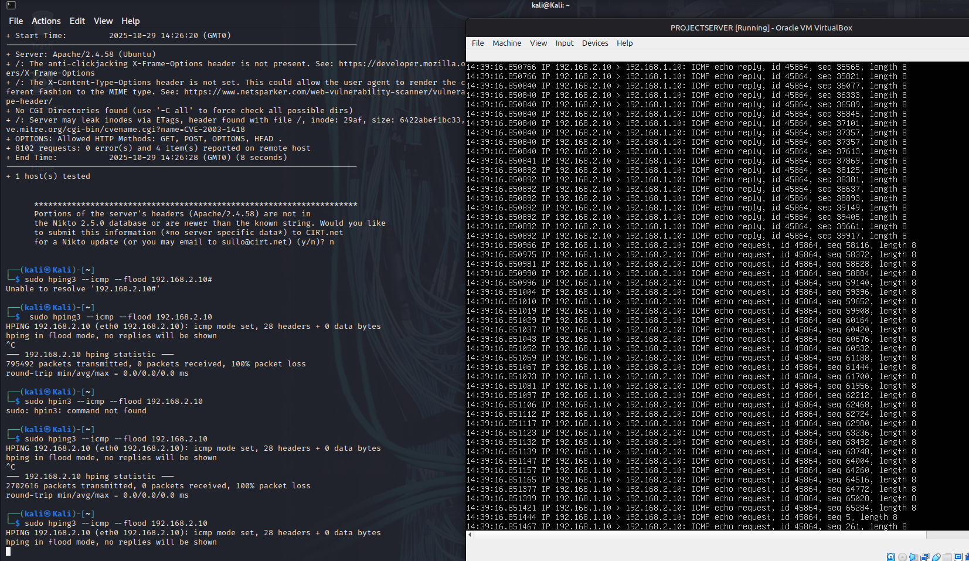
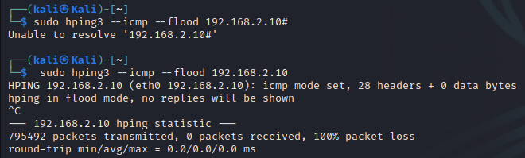
This time 1 million packets less were sent but most were dropped so the flood was defended against successfully

Comparison
Test type | No firewall results | With firewall results | Improvement
Nmap port scan | 1000 ports scanned port 80 visible done in 13.24s | Ports silently filtered only port 80 accessible longer scan time | Big
Nikto assessment | Showed all services apache version exposed os revealed | Same vulnerabilities web services still visible | Limited
ICMP flood attack | 1.7 mil packets sent target overwhelmed | 700k packets sent most packets dropped everything still worked | Big

Conclusion
The tests prove that nftables works as intended for firewall. It successfully protected the system against network attacks. Port scans became slower and started to work worse. The ICMP flood attack was blocked and the server stayed online and didn’t crash during the attack.
However, the firewall could not stop the Nikto web scan. this happened because I allowed web traffic through port 80. The firewall cannot tell a normal website visitor from an attacker scanning for weaknesses.
This means that a firewall alone is not enough for full security. This is why more tools should be used for example a web application firewall, keep the software updated and try your best to hide server information while not relying on only one line of defence, nftables is a good first step for security but you need more layers to make sure your safe.

Smoothwall
Samuel Sebastine (B00174492) (G8)
Introduction Smoothwall Firewall
Smoothwall is a firewall solution that was designed to help and provide network protection for organizations. It was designed as a dedicated firewall distribution, smoothwall offers advanced filtering, intrusion prevention and web content filtering in a user-friendly package (Stallings,2022). Unlike most firewalls smoothwall has complete security that integrates multiple layers into one manageable platform.
Smoothwall stands out because of its features which includes packet inspection, deep packet inspection and application filtering capabilities (Anderson,20220). Its web-based management interface allows for administrative access to configure security policy without knowing too much about what they are doing which makes it easier for beginners and small businesses.

Aims
My aim was to test how impactful the firewall was of smoothwall through different types of testing unfortunately some didn’t go as planned but I was still able to see some of its capabilities. Testing took place on 3 different Vms mainly on Kali Linux and smoothwall firewall. Xubuntu was an internal web server, Smoothwall firewall server and Kali Linux was the attacker.
The internal firewall server and firewall server operated on an internal network while the firewall’s external interface faced the attacker network which is there to try make it somewhat realistic although I had some issues with the internal server testing with Xubuntu.

The following tests were done:
- Port scanning with nmap
- Service detection to identify any information leakage
- Firewall evasion techniques using advanced nmap
- Web service connection attempts
- Port forwarding configuration and verification
Firewall’s performance was analysed before and after security rules to see the impact of blocking access from the attacker while maintaining network services.

Topology
The testing network was configured as follows:
-Internal Web Server IP: 192.168.10.20
-Smoothwall Firewall Internal IP: 192.168.10.1
-Smoothwall Firewall External IP: 192.168.0.83
-Kali Linux Attacker IP: 192.168.0.x (external network)
The Smoothwall firewall acted as a gateway between the internal (trusted) and external (untrusted) networks, filtering all traffic through its forward chain and custom security policies.

Testing Setup
Smoothwall installation and config, setup using smoothwall express 3.1 and then I setup the process configuring network interfaces and assigning the interface to 192.168.10.1 Smoothwall installation screenshots of installation and assign green /red config i also added root password. After successful installation, I configured the firewall rules to implement a default-deny policy while allowing specific necessary services. Additionally, adding the iptables rules and firewall rules.
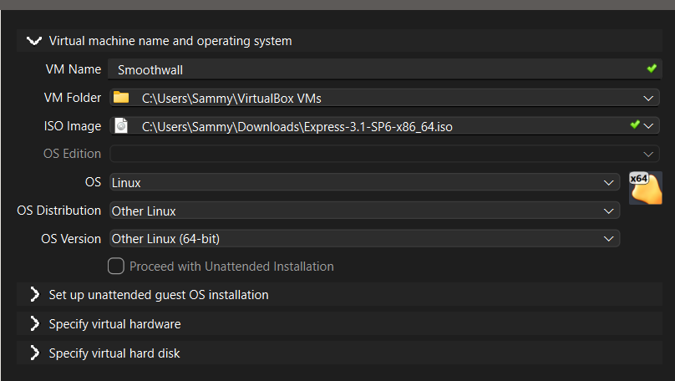
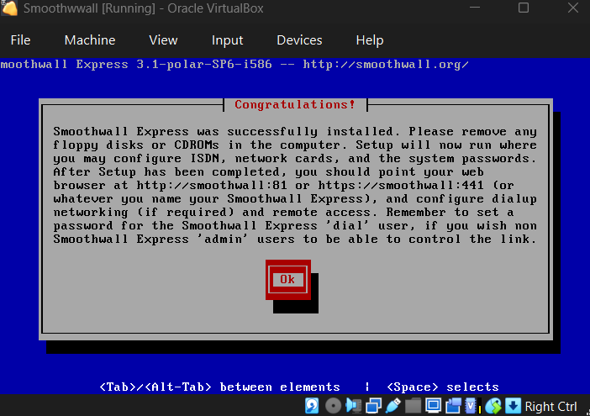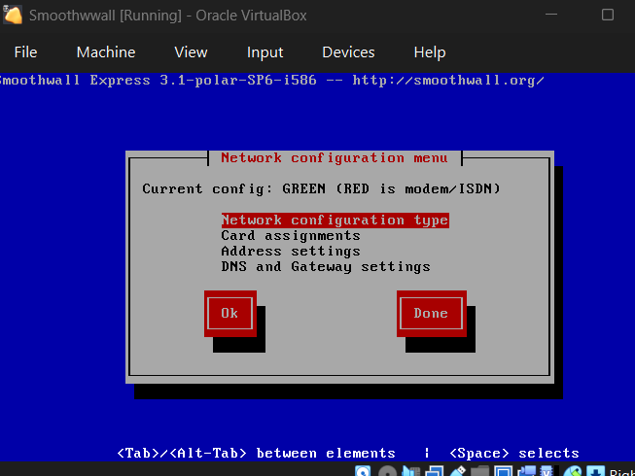
(Network Ip config settings)
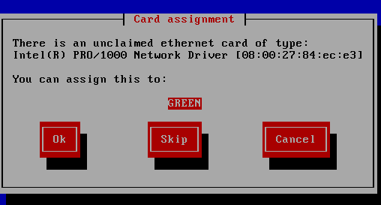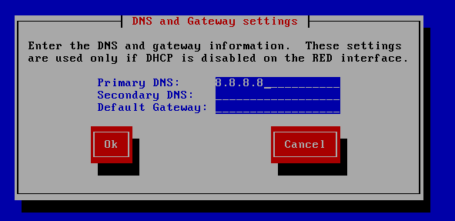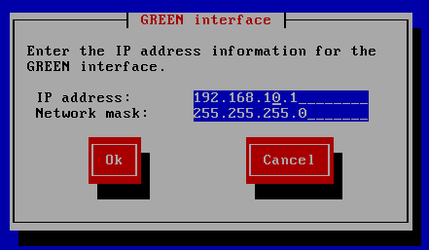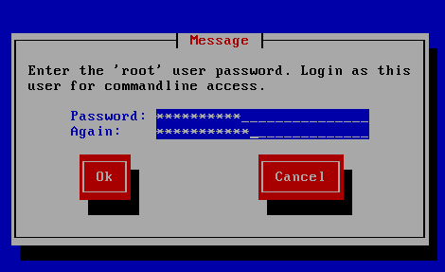

Iptables rules
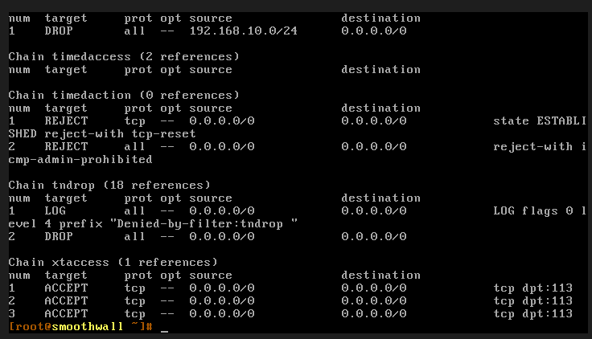
(Adding fire rules) 

Testing with Firewall Enabled
Test 1: Basic Connectivity and Nmap Comprehensive Port Scan
Did basic connection testing and nmap port scans to check if the firewall was accessible as well as port scanning. Results show 985 filtered ports and 1 closed port 113, this indicates successful blocking:
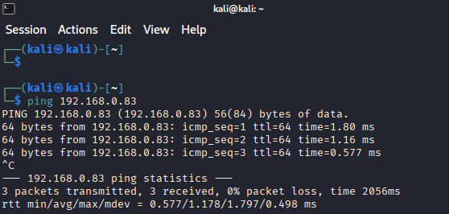
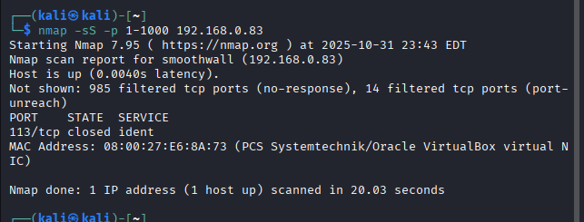
Test 2: Targeted Service Port Scanning
Target port scanning checking for specific ports to verify rules, all the tested ports show filtered which confirm the rules were working and enforced.
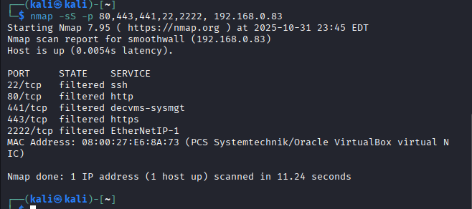
Test 3: Service Version Detection
I attempted service version detection to see running services and any potential leakage Scan shows all ports were filtered with no leakage seen at all during the scan the firewall preventing any access from the attack.
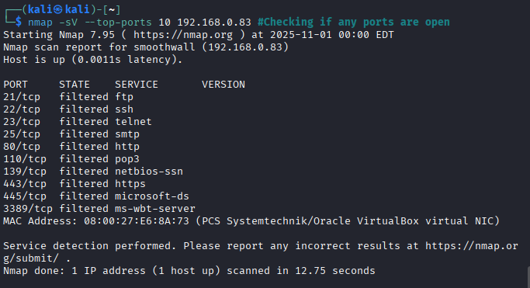
Test 4: Operating System Fingerprinting
I next attempted OS detection to assess any info leakage about the underlying system.OS detection showed results that were apparently unreliable with multiple matches, which indicates the firewall obscures system info that could help attacks when they are trying to implement exploits against the firewall:
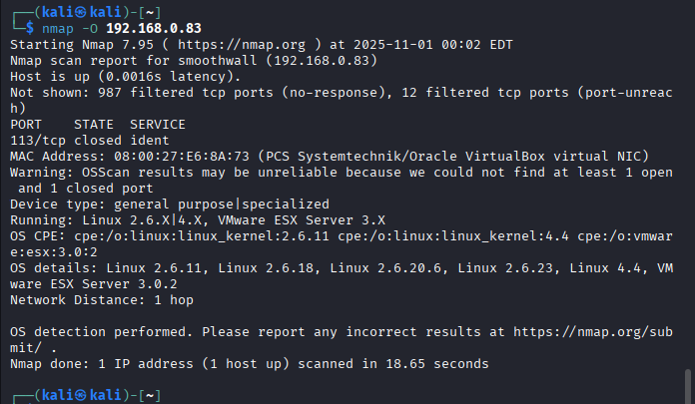
Test 5: Firewall Evasion Techniques - Fragmented Packets
I next attempted packet scanning the scan showed basically identical results to normal scanning showing the firewalls deep packet scanning capabilities can reassemble and analyse fragmented packets effectively.
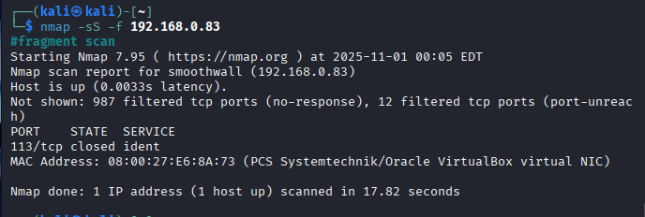
Test 6: Firewall Evasion Techniques - Aggressive Timing
Did T4 timing scanning didn’t really alter the results so thinking about this in the future maybe use t 2 or 3 to see if that would change the conditions.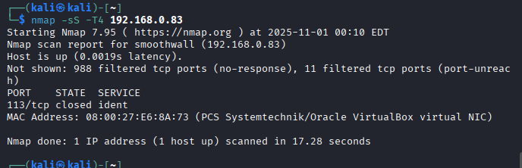
Test 7: Firewall Evasion Techniques - Decoy Scanning
Attempted decoy scanning which failed to produce and big difference showing the firewall can understand the difference between spoofed and legitimate traffic.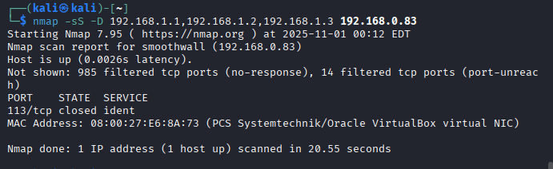
Test 8: Firewall Evasion Techniques - Parallel Scanning
Testing parrel scanning had no huge difference in effectiveness and firewall had consistent results.
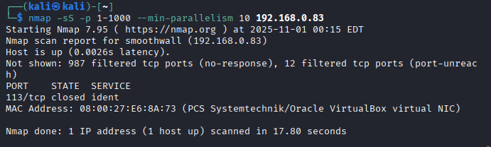
Test 9: Web Service Access Attempts
Attempts to reach smoothwall web management interface and test http get and post request were blocked. All methods were blocked using get and post requests resulted in connection failures as the firewall was too effective blocking unauthorized access to management interfaces regardless of http method used.
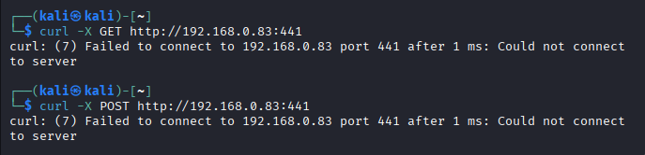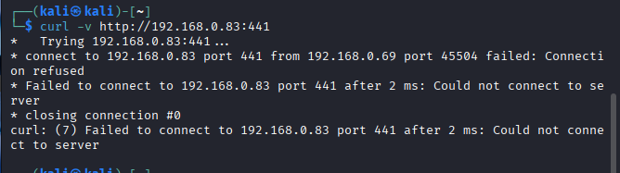
Test 10: UDP Service Scanning
Conducted UDP service scanning both udp ports showed as closed demonstrating the firewalls protection from both tcp to udp protocols: 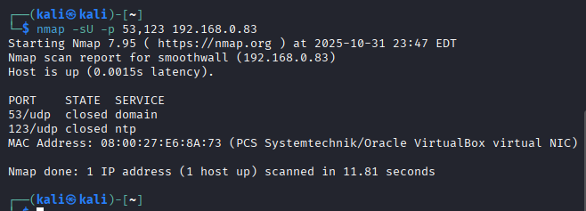
Test 11: Direct Service Connection Attempts
All connections from telnet were refused as the firewall was blocking connections: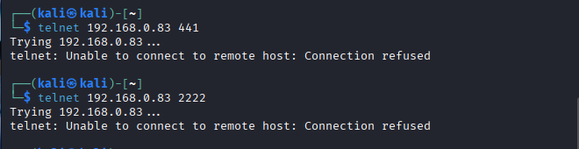
Test 12: Alternative Port Testing
Port testing on port 8080 remained filter even though I did so many attempts, but I think this demonstrates the security layers preventing dangerous connection as it wouldn’t make sense to allow access to something such as this.
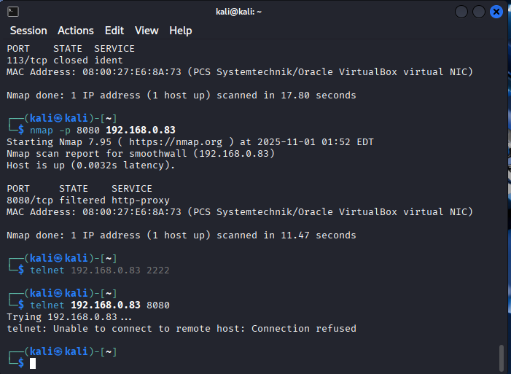
Test 13: Targeted Service Scan Validation
I did some additional targeted scanning to see the consistency in the filtering, all ports remained filtered across multiple scan attempts confirming consistent security.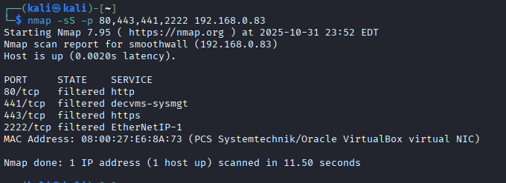

Firewall enabled vs disabled
As my attempt to compare an attack running through kali linux to attack the firewall to access xubuntu web server didn’t work I compared my smoothwall with my group by showing differences by temporarily disabled the firewall rules to establish a baseline comparison:
(Image showing me disabling firewall, with firewalls disabled the security changed dramatically.)

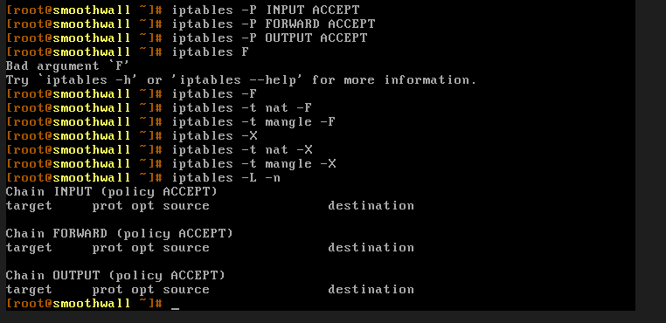
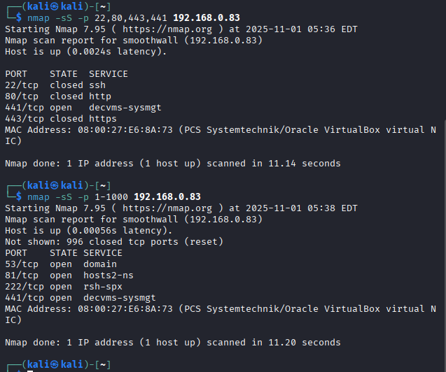

The comparison between firewall on vs off
State | Open ports | Filtered ports | Closed ports | Security risk management
Firewall on | 0 | 999 | 1 | Excellent
Firewall off | 4 | 0 | 996 | High risk

Services Exposed Without Firewall:
- Port 53/tcp: DNS service (domain)
- Port 81/tcp: hosts2-ns service
- Port 222/tcp: rsh-spx service (remote shell)
- Port 441/tcp: decvms-sysmgt (Web Management Interface)
Effectiveness Calculation:
- Threats Blocked: 4 critical services
- Total Threats: 4 exposed services
- Effectiveness Rate: (4/4) × 100 = 100%

Result Analysis
Test Type | Command Used | Firewall ON Results | Firewall OFF Results | Effectiveness
Comprehensive Port Scan | nmap -sS -p 1-1000 | 999 filtered, 1 closed | 4 open, 996 closed | 100%
Service Port Scan | nmap -sS -p 22,80,443,441 | All filtered | Multiple open | 100%
Service Detection | nmap -sV --top-ports 10 | No information leaked | Service details exposed | 100%
OS Fingerprinting | nmap -O | Unreliable results | Accurate detection | 100%
Fragmented Packets | nmap -sS -f | Evasion defeated | N/A | 100%
Aggressive Timing | nmap -sS -T4 | Consistent performance | N/A | 100%
Decoy Scanning | nmap -sS -D | No evasion success | N/A | 100%
Web Access | curl -X GET/POST | All blocked | Access possible | 100%
Udp scanning | Nmap -sU -p 53,123 | Ports closed | Services exposed | 100%

Conclusion
The testing demonstrates that Smoothwall provides robust firewall protection with a high rate in blocking unauthorized external access. The comparative analysis reveals the security difference between enabled and disabled states, with four critical services becoming immediately exposed when the firewall was disabled.
Smoothwall excelled in preventing service enumeration, blocking unauthorized access, and maintaining security against evasion techniques. The system's default-deny posture proved completely effective, with zero services accessible externally when the firewall was enabled.
The firewall demonstrated consistent performance across all test scenarios, including evasion techniques and high-volume scanning. Its ability to maintain security posture under various attack conditions confirms its suitability for enterprise environments where reliable protection is essential.
The exposure of port 441 (web management interface) and port 2222 (remote shell service) when the firewall was disabled highlights the extreme risk of operating without proper firewall protection. Smoothwall successfully mitigated these risks completely when enabled.

Final conclusion
Overall, each firewall presented itself with challenges and benefits, our group demonstrated different hack attacks on our fire walls and trouble-shoot the issues such as creating a whitelist Ip and blocking and logging packets.
however, one firewall showed the best result which was smooth wall with it being effective in every it was given. test unlike ipfire which found that unless you knew your Linux commands or knew how to access your online rule maker you would be in trouble
with Nftables it was successful however it limited in its performance in stopping a nikto attack but this was unavoidable because the website couldn’t tell the difference from a malicious and normal pc

Reference list

- Beaver, K. (2007). Hacking for dummies. Hoboken, N.J.: Wiley ; Chichester. (Accessed on Wed 29th October)
- Nmap (2024). Nmap. Nmap.org. Available online at: https://nmap.org/. (Accessed on Thurs 30th October)
- Kali (2024). hping3 | Kali Linux Tools. [online] Kali Linux. Available at: https://www.kali.org/tools/hping3/. (Accessed on Sun 26th October)
- www.ipfire.org. (n.d.). www.ipfire.org - Welcome to IPFire. [online] Available at: https://www.ipfire.org/. (Accessed on Fri 24th October)
- Netfilter project (2025) what is nftables. Available online at https://wiki.nftables.org/wiki-nftables/index.php/What_is_nftables%3F (Accessed on
Sat 29th October)
- Y Combinator (2017) nftables discussion [online]. available at https://news.ycombinator.com/item?id=14286389 (Accessed on Wed 29th October)
- Anderson, R. (2020) Security Engineering: A Guide to Building Dependable Distributed Systems. 3rd edn. Chichester: Wiley. (Accessed on Mon 27th October)
- Greene, T. (2023) 'Modern penetration testing methodologies for network infrastructure, International Journal of Cyber Security, 8(1), pp. 112-125. (Accessed on Mon 27th October)
- Skoudis, E. (2019) Counter Hack: A Step-by-Step Guide to Computer Attacks and Effective Defenses. 2nd edn. New Jersey: Prentice Hall. (Accessed on Tues 28th October)
- Stallings, W. (2022) Network Security Essentials: Applications and Standards. 6th edn. London: Pearson Education. (Accessed on Sun 26th October)
- Zimmerman, C. (2021) The evolution of firewall technology in enterprise security, Journal of Network Security, 15(2), pp. 45-58. (Accessed on Wed 29th October)

